FOR GROUP LEADERS
How to use this November Action Sheet
Remove this page before distributing
As this November Action Sheet goes to press on November 5, we don’t yet know whether carbon pricing will be in the reconciliation framework or not. So, we’ve designed the actions below to support your chapter’s climate advocacy work in general. To stay current on the status of reconciliation, check out Tony Sirna’s posts in the Forum of the GL Group.
Speaking of climate advocacy, we are excited to hear from our terrific keynote speaker, celebrate our 2021 progress, get all the latest updates from D.C. and start some contingency planning for a post-reconciliation world at our free online National Conference, November 13-14. Your volunteers can register at cclusa.org/november up until Nov. 13, so please invite everyone on your chapter roster to attend.
Our overarching goal is to ensure that carbon pricing is enacted, stays enacted and gets stronger over time, so this month’s Support and amplify our year-end fundraiser is aimed at securing the budgetary resources we need to support your work. If all of your active volunteers donate as they are able and spread the word on Giving Tuesday, we’ll be well on our way to building the organizational support you need. Before your gathering, ask a few volunteers to be prepared to briefly share why they volunteer with CCL.
Social media boosts all of our levers of political will, so the goal of this month’s Take climate action using social media is to get more of your volunteers to use social media and to get your social media veterans to try some new types of posting. Consider asking one of your social media gurus to lead this action.
Notes: Please notify your volunteers that, (1) our new Get Loud Take Action page cclusa.org/action has the latest national actions, and (2) our “Who supports a carbon price” page on the public CCL site is all new.
Follow-ups from October: (1) Invite your volunteers to post a screenshot of the Nat’l Conference to their social media. (2) Be sure to share the positive press they generated with nearby liaisons for delivery to Congress. (3) Ask volunteers to tweet Biden’s correspondence office @DearPOTUS46 if they haven’t yet.
A sample meeting agenda (suggested time is 35-60 minutes)
- Ask a few folks to say what they liked about calling their Senators or writing to Biden - 5-10 mins
- If your gathering is after the November 13-14 Conference, invite your attendees to share something they learned or are thinking about. If you have a big group, use breakout rooms - 5-10 mins
- Do the two actions in the Action Sheet - 5-10 mins each
- Do the Communications Exercise in the Action Sheet - 10 mins
- Round robin - what is one action you will take before our next chapter meeting? - 5-10 mins

ACTION SHEET, NOVEMBER 2021

National Conference, Nov 13-14, 2021
10:00 a.m. Pacific / 1:00 p.m. Eastern
To join our November National 2021 Conference, register at cclusa.org/november
Note: To improve audio/video quality, close all applications and other browser windows
Note: See these instructions to see how to turn on closed captions and adjust the font size
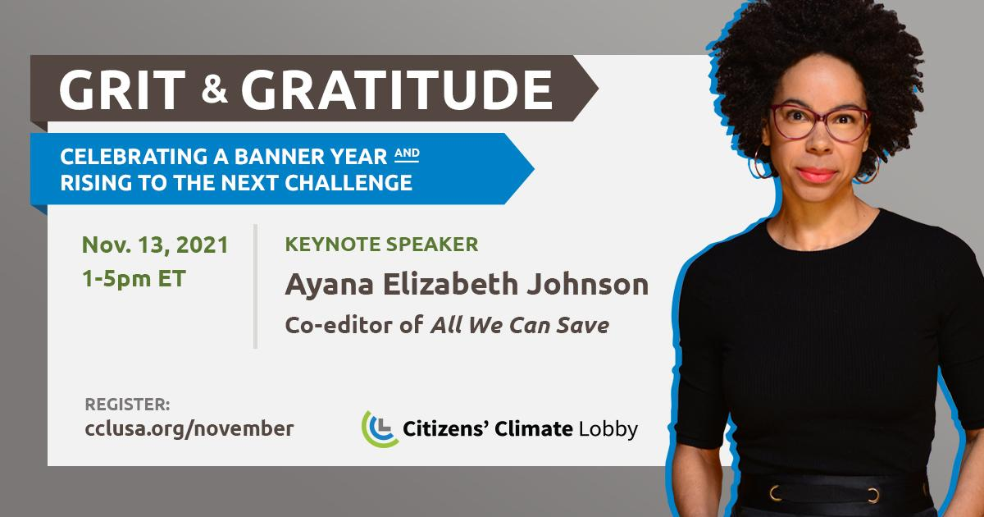
Actions for your chapter gathering:
- Support and amplify our year-end fundraiser!
- Take climate action using social media
- Communication exercise: Practice using your own climate story to connect
If your Action Sheet is printed and you’d like to be able to click the links, you can download this document at cclusa.org/actionsheet. There’s a Spanish version there, too!

Support and amplify our year-end fundraiser!
Our year-end fundraiser kicks off on Giving Tuesday — November 30 — and runs through the end of the year. At this critical moment in climate history, we encourage every CCL volunteer to donate, even if it’s a small amount. Please give what you can and help us spread the word!
As you know, the policy we have long advocated for — carbon fee and dividend — is currently being considered in ongoing budget reconciliation negotiations, thanks to the dedicated work of CCL volunteers and staff. We have never been closer, but we need your help to make it across the finish line. We need to bring in $1.5 million by year-end, and we hope to raise $300,000 on Giving Tuesday alone!
During your gathering:
- Ask a few people to share why they volunteer with CCL and how CCL has empowered them.
- Determine who will distribute the email template below to everyone on your chapter roster. Encourage people to personalize the template and send it to their friends, family, allies, professional network, and to their social media accounts on Giving Tuesday. Be sure to include the donation link: citizensclimate.org/give
- Get ready to repost, retweet, and share CCL’s social media posts - on Giving Tuesday and throughout the appeal which runs through the end of the year.
- Invite everyone to put November 30 (Giving Tuesday) in their calendar as a reminder to make a donation.
Email template
Here’s a short fundraiser description to share with friends, family, allies, professional networks, and on social media. Feel free to personalize it with what CCL means to you, and why you volunteer and/or donate! And please follow up with a phone call.
Subject: Can you pitch in for our climate at this historic moment?
Friends,
As you may know, I volunteer for an organization called Citizens’ Climate Lobby (CCL), working to build political will for effective climate solutions in Congress. We’ve made huge strides over the last year, but we’re not across the finish line yet. To avoid the worst effects of climate change, we still need meaningful legislation enacted to significantly reduce emissions in the coming years. And right now, we’ve never been closer. But, we need your help.
We’re fundraising for Citizens’ Climate Education, the 501(c)(3) sister organization of CCL. So, this means all donations are tax-deductible! We have a huge goal of raising $300,000 today (on Giving Tuesday), and $1.5 million by year-end. I’m writing to ask if you can pitch in today, to get us closer to our goal and closer to a more livable planet. You can make your donation – of any amount – online at citizensclimate.org/give.
Thank you for considering a gift to CCE at this critical moment. Every donation helps!
Additional Resource
CCL Community’s Raise Funds for CCL Nationally training page.
Take climate action using social media
SOCIAL MEDIA ACTION
You’ve emailed and called Congress and emailed the President. What else can you do to advocate for carbon pricing? Social media is an important way to directly build political will for climate action and enables you to amplify your work pulling our five levers. Get your chapter’s social media newbies and veterans taking action.
During your gathering do one or more of these social media actions
- Step up your chapter’s social media game. Discuss volunteer use of social media in your chapter and make a plan to boost it to the next level. For example, you might ask someone who is knowledgeable on social media to organize an online co-working party and invite everyone who needs help getting started. Then, during the party, help everyone get an account on Twitter, Facebook, Instagram or TikTok, install the app on their phone, create a message and post it to their new social media account.
- Click one of the Fresh Social Links below. These links will always lead to a fresh social media post in our Social Media Toolkit. Click a link to see a list of posts from members of Congress, journalists, CCLers or other prominent social media influencers.
Twitter | Facebook | Instagram | TikTok
cclusa.org/freshtweet | cclusa.org/freshfb | cclusa.org/freshig | cclusa.org/freshtt
Then click one of the links in the list and, when you see the post, like it, repost it, comment on it, and share it with your followers/friends. Be sure to include the hashtag #PriceOnCarbon and, if appropriate, your MOCs’ social media handles.
- Enter CCL’s Carbon Cashback contest. CCL is running a Carbon Cashback giveaway on Instagram. We want to show that if #carboncashbacks pass in budget reconciliation, Americans could get as much as $250/year CASH, while helping reduce emissions 50% by 2030! The contest starts on Tuesday, November 9th and runs through December 18th. Each week, we'll be giving away $250 to one lucky winner. To enter:
- Get the Instagram app on your phone if you don’t have it, create an account and follow the CCL account @citizensclimate (search for @citizensclimate and then click the blue “Follow” button).
- Look for a new CCL post about the contest each Tuesday starting on November 9th and when you find it, tag a friend in the comments (tap the comment icon that looks like a speech bubble and type your friend’s @name). Each tag = 1 entry.
Check out our contest page for the complete rules. Then, follow CCL on Instagram and get ready to spread the word to your friends about the "greenest" climate policy in the world. Maybe you’ll be a winner! (Please make sure your Instagram account is public for the week(s) you are entered in the contest.)
Additional Resources
- CCL Community’s Ten Budget Reconciliation Actions Social Media Toolkit resource
- CCL Community’s Social Media for Volunteers & Chapters topics
Practice using your own climate story to connect
COMMUNICATION EXERCISE
Stories are a great way to personalize climate change, bring it close to home, connect with your listeners, and evoke emotions that can motivate people to change their point of view or take action. With practice, you can learn to use your story to start a climate conversation and you may even find yourself in situations where you can tell your story to family over the holidays or during tabling and presenting in the new year.
Here’s a simple outline that you can follow to develop your story.
- Describe a place you love that is changing
- Relate it to climate change
- Explain why it matters
- Add a solution or personal action to convey hope for a better future
Here’s an example story so you can see what that might look like:
100 miles north of New York City, Lake Huntington was a gathering place every winter of my childhood. The town held an annual Ice Carnival. We ice skated, played hockey, fished, and rode snowmobiles. In the dead of winter, the frozen lake gave us a place to meet up with friends and to get fresh air during the long, dark winters. Last year I visited my home town for two months during the winter. By the end of January, there was a partial thin layer of ice that never reached the opposite shore. Townspeople told me that due to climate change the lake is no longer safe for ice skating, and they can’t remember the last time the ice cover was strong enough to support a snowmobile. The Ice Carnival has been canceled indefinitely. But, winter is something worth fighting for! Since 2013, I have been asking members of Congress to put a price on carbon. This won’t solve all our problems, but it will set in motion a major shift in how we get energy.
Suggestions for how to practice
We know that people learn best by saying the words out loud themselves. For this exercise, read the instructions below to meeting attendees, have two people model it, and then have everyone practice.
Instructions: With a partner, take turns following the 4-step outline above to turn your feelings for a place into a story. Afterward, take turns asking each other questions about your partner’s story.
If you use Zoom breakout rooms (see Zoom’s training page on “Breakout Rooms” to learn how)
Put everyone into breakout rooms, two people per room, for six minutes. When everyone comes back together, ask a few people to share what they learned.
If you use Zoom but you don’t use breakout rooms, invite a few attendee pairs to follow the instructions
Additional Resource
CCL Community’s Telling Compelling Stories training

