Contact: (Name)  (Name of chapter) CCL  Phone (phone number)  (chapter)@citizensclimatelobby.org |  |  | 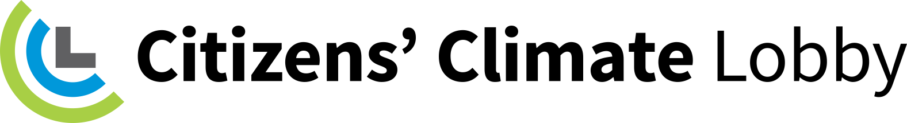  https://citizensclimatelobby.org/

Press Release

Citizens’ Climate Lobby Climate Advocate Training to be held in (city)
(City, State) – Date: Citizens’ Climate Lobby (CCL) will hold a Climate Advocate Training for residents of (city) at (time) on (day, date) at (place). People interested in climate solutions are encouraged to attend.
CCL is a nonprofit, nonpartisan, grassroots advocacy organization, with hundreds of chapters worldwide, which is working to build the political will to respond to climate change.
Their consistently respectful approach to climate education is designed to create a broad, sustainable foundation for action across all geographic regions and political inclinations. By building upon shared values rather than partisan divides and empowering volunteers to address the concerns of their local communities, CCL works towards the adoption of fair, effective and sustainable climate change solutions, including the Energy Innovation & Carbon Dividend Act.
This legislation is a revenue-neutral, market-based, non-regulatory approach that reduces greenhouse gas emissions, while creating jobs and benefiting the economy. 100% of the net fees charged fossil fuel emitters are to be held in a Carbon Fees Trust fund and returned directly to households as a monthly dividend. In order to generate the political will necessary for passage of the historic Energy Innovation Act, CCL trains and supports volunteers to build relationships with elected officials, the media and their local community members.
For more information on CCL and its proposed legislation, visit https://citizensclimatelobby.org/.
###

